If raise error like below picture:
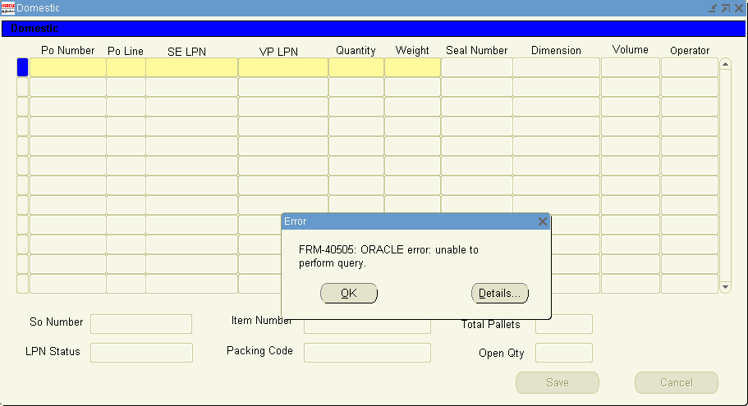

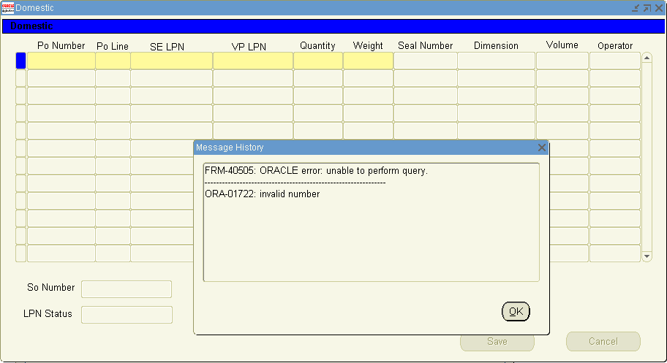
Step1. Find error source from.
Run below script:
select * from BMC_AUTO_LPN_NEW wapl
where (status <> 'PICKED' or status is null)
and not exists (select 'X'
from WMS_LICENSE_PLATE_NUMBERS wlpn
where wlpn.LICENSE_PLATE_NUMBER = wapl.vp_lpn
and wlpn.lpn_context = 4)
and not exists (select 'X'
from bmc_auto_so_new_v bas
where bas.so_number = wapl.so_number
and nvl(bas.status,'A') = 'SHIPPED'
);
if raise error ‘invalid number’ then run below script :
SELECT bal.so_number,
COUNT (bal.vp_lpn) total_pallets,
SUM (bal.quantity) total_qty
FROM bmc_auto_lpn_new bal
GROUP BY bal.so_number;
Must be raise error ‘invalid number ’.

If you can find above error, it must be data error in table ‘bmc_auto_lpn_new’ column :‘quantity’.
Run below script, find out the error data :
select po_number,
po_line_number,
so_number,
VP_LPN,
SE_LPN,
quantity
from bmc_auto_lpn_new;

Step2. Update error data, before update please backup first :
UPDATE BMC_AUTO_LPN_NEW
SET QUANTITY=:P_QUANTITY
WHERE PO_NUMBER=:P_PO_NUMBER
AND PO_LINE_NUMBER=:P_PO_LINE_NUMBER
AND SO_NUMBER=:P_SO_NUMBER
AND VP_LPN=:P_VP_LPN
AND SE_LPN=:P_SE_LPN;

Commit;
Step3. Check it.

